Churn Prediction Model Report

1. Introduction
Customer churn is a critical issue for many businesses, especially those in highly competitive markets. Identifying customers who are likely to churn can help in taking proactive measures, such as targeted retention strategies and personalized offers. This report presents a predictive model for customer churn, using a machine learning approach to provide insights into which customers are at risk of leaving. The model's purpose is to help the business focus retention efforts more effectively and reduce customer attrition.

2. Selected Algorithm: Random Forest Classifier
Algorithm Overview:
- Random Forest is an ensemble learning method that combines multiple decision trees to create a robust classification model. Each decision tree is trained on a random subset of the training data, and the final prediction is made by aggregating the predictions of all trees, usually through a majority vote.
- It handles both classification and regression tasks and is known for its accuracy, flexibility, and ease of interpretation.
Rationale for Choosing Random Forest:
- Handles Complexity: The customer churn problem involves a variety of features, including numerical variables (e.g., age, amount spent) and categorical variables (e.g., marital status, service usage). Random Forest handles this complexity well, allowing interactions between variables effectively.
- Feature Importance: Random Forest provides insights into feature importance, which can help stakeholders understand which factors most influence customer churn, enabling data-driven decision-making.
- Resilience to Over-fitting: By averaging the predictions of multiple trees, Random Forest is less likely to over fit the training data compared to individual decision trees.
- Performance: It has been shown to achieve high accuracy on complex datasets, making it suitable for applications where prediction quality is critical.

3. Data Preprocessing
- Data Cleaning: Missing values were handled by imputing with the mean for numerical features. Dates (InteractionDate and LastLoginDate) were converted to numerical differences to create a feature called DaysSinceLastLogin.
- Feature Engineering: Categorical variables (e.g., MaritalStatus, ServiceUsage, Gender) were encoded using Label Encoder to convert them into numerical format.
- Feature Scaling: Numerical features like age, login frequency, and amount spent were standardized using StandardScaler to ensure uniformity across features.
- Train-Test Split: The dataset was split into training (80%) and testing (20%) sets to evaluate model performance on unseen data.

4. Model Training and Performance Metrics
Model Training:
- A RandomForestClassifier was trained using the processed dataset with 1000 estimators and a random state of 42 for reproducibility.
- The model was trained on the following features: Age, Gender, Marital Status, Income Level, Service Usage, Amount Spent, Product Category, Resolution Status, Login Frequency, Income Level Class and Days Since Last Login.
Performance Metrics:
Accuracy: The model achieved an accuracy of 75% on the test set, indicating that it correctly classified churn and non-churn customers 75% of the time.
Precision: Precision for predicting churn was 0.76, indicating that 75% of customers predicted as churned were actually churned.
Recall: Recall for predicting churn was 0.97, suggesting that the model identified 97% of all actual churners.
F1 Score: The F1 score, which balances precision and recall, was 0.86, making it a reliable measure of the model's performance for imbalanced datasets.
Confusion Matrix:
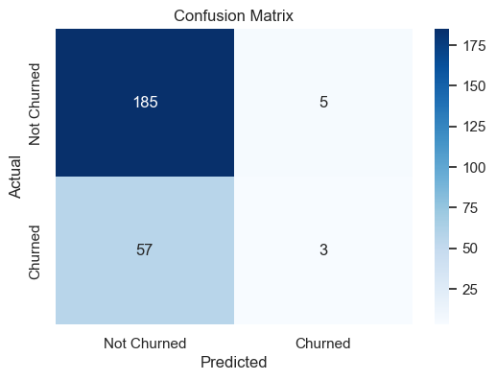
This is summarized in the confusion matrix:
 | Predicted: Not Churned | Predicted: Churned
Actual: Not Churned | 185 | 5
Actual: Churned | 57 | 3
Feature Importance:
- The model identified the following as the most important features influencing churn:
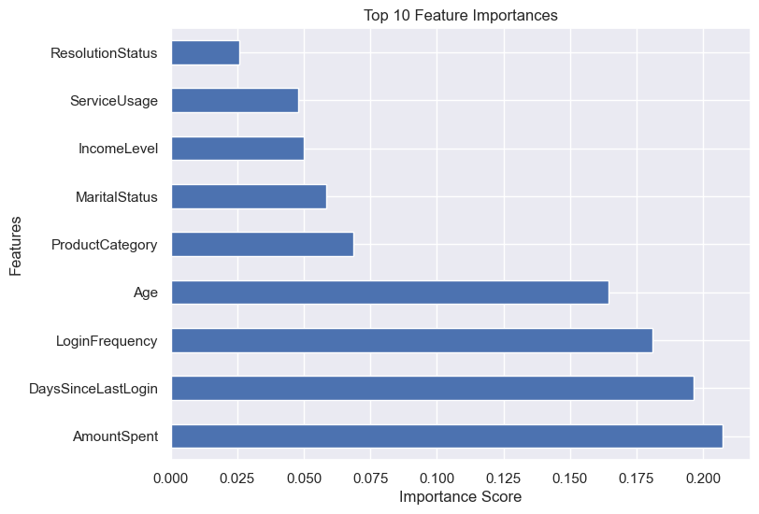

5. Recommendations for Business Decision-Making
Using Model Predictions for Retention Strategies:
Targeted Retention Campaigns:
- Focus on customers identified as high churn risk by the model, especially those with declining login frequency and spending habits.
- Offer personalized discounts or loyalty rewards to these customers to increase continued engagement.
Service Optimization:
- Analyze service usage patterns and focus on improving the experience on platforms where churn rates are higher.
- For example, Online banking users are more prone to churn, explore improving banking usability or offering exclusive promotions for online banking users.
Engagement Campaigns:
- For customers with a high number of days since their last login, design re-engagement campaigns such as email reminders, push notifications, or special offers to encourage them to log back into the platform.
- Highlight new features or products that may reignite interest.
Resource Allocation:
- Prioritize customer support resources for customers who have unresolved inquiries, as resolution status plays a significant role in churn.
- Improving response time and resolution rates can directly impact customer satisfaction and retention.
Potential Areas for Improvement:
Model Enhancement:
- Consider testing other machine learning algorithms such as XGBoost or Gradient Boosting, which may provide better predictive power.
- Implement hyperparameter tuning (e.g., using GridSearchCV) to optimize the Random Forest model further.
Feature Expansion:
- Include additional features such as customer feedback ratings or sentiment analysis from customer interactions to capture more nuanced predictors of churn.
- Use interaction frequency with different product categories or customer support interactions for better insights.
Data Augmentation:
- Collect more data on customer preferences, browsing history, and previous retention offers accepted. This data could enrich the model and improve prediction accuracy.
- Use a time-series analysis on login and spending trends to capture seasonal behavior and predict churn more accurately.

Conclusion
The Random Forest-based churn prediction model provides a reliable way to identify customers who are likely to leave the platform. And from the model it is seen that out of the total number of customers that 3 are predicted to churn. Also, amount spent, days since last login, login frequency, and age are the most features influencing customer churn.

